R. Reports Menu: 9. Employee Listing

Table of Contents
Employee Listing 3
Individual 4
Department 5
All 7

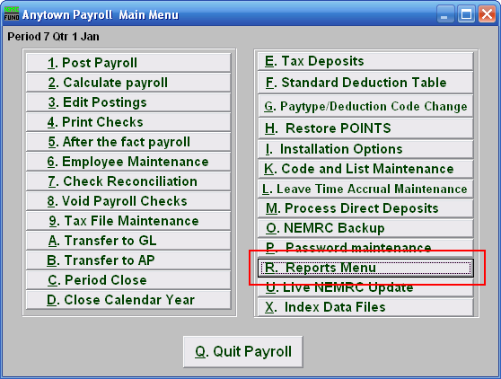
Click on “R. Reports Menu” off the Main Menu and the following window will appear:

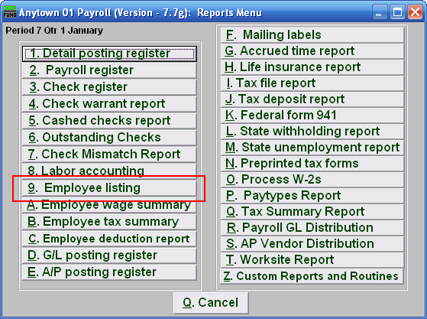
Click on “9. Employee listing” on the Reports Menu and the following window will appear:

Employee Listing

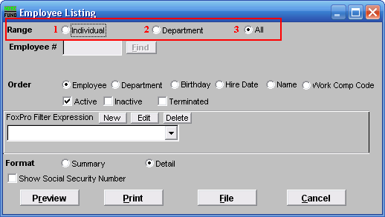
- Individual: Click on this option if you want to have this report be for an Individual employee.

- Department: Click on this option if you want this report to be for all employees in a single Department.

- All: Click on this option if you want this report to be for All employees.

Refer to the section below that relates to your choice.

Individual
If you chose “Individual” the following window will appear:

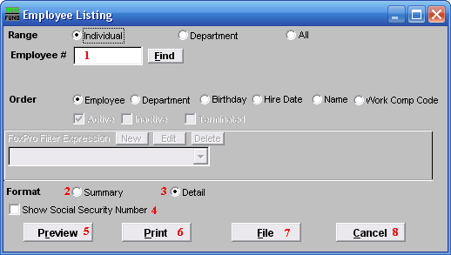
- Employee #: Select the individual employee to report when the range option is set to individual.

- Format: Summary: Summary format includes employee number, name, address, social security number, phone number, workers compensation code, birth date and hired date.

- Format: Detail: Detail format includes all information on the “Personal” tab in “6. Employee Maintenance” and selected information from the “Deduction” and “Paytypes” tabs. The entire “History” tab is printed.

- Show Social Security Number: Click to check this option and have this report show the Employee’s Social Security Number.

- Preview: Click this button to preview this report. Refer to GENERAL PREVIEW for more information.

- Print: Click this button to print this report. Refer to GENERAL PRINTING for more information.

- File: Click this button to save this report on this computer. Refer to GENERAL FILE for more information.

- Cancel: Click “Cancel” to cancel and return to the previous menu.

Department
If you choose “Department” the following window will appear:

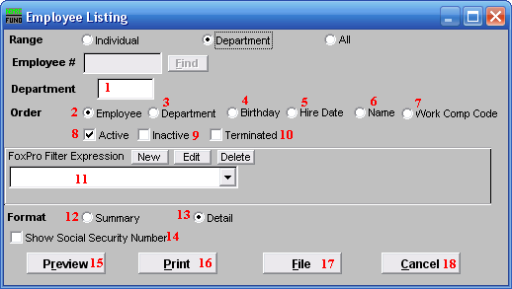
- Department: Enter a department code that has been assigned to the group of employees to report.

- Order: Employee: Display by employee number.

- Order: Department: Display by department number then employee order.

- Order: Birthday: Display in order of date of birth.

- Order: Hire Date: Display in order of date of hire.

- Order: Name: Display in order of employee last name then first name.

- Order: Work Comp Code: Display in order of the workers compensation code assigned to the employee.

- Active: Select this to include active employees.

- Inactive: Select this to include inactive employees.

- Terminated: Select this to include terminated employees.

- FoxPro Filter Expression: A conditional reporting expression developed with NEMRC support. This evaluates information to determine if the employee should be included in the report. Contact NEMRC support to learn more about this option.

- Format: Summary: Summary format includes employee number, name, address, social security number, phone number, worker s compensation code, birth date and hired date.

- Format: Detail: Detail format includes all information on the “Personal” tab in “6. Employee Maintenance” and selected information from the “Deduction” and “Paytypes” tabs. The entire “History” tab is printed.

- Show Social Security Number: Click to check this option and have this report show the Employee’s Social Security Number.

- Preview: Click this button to preview this report. Refer to GENERAL PREVIEW for more information.

- Print: Click this button to print this report. Refer to GENERAL PRINTING for more information.

- File: Click this button to save this report on this computer. Refer to GENERAL FILE for more information.

- Cancel: Click “Cancel” to cancel and return to the previous menu.

All
If you choose “All” the following window will appear:

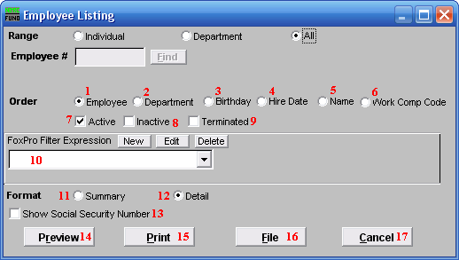
- Order: Employee: Display by employee number.

- Order: Department: Display by department number then employee order.

- Order: Birthday: Display in order of date of birth.

- Order: Hire Date: Display in order of date of hire.

- Order: Name: Display in order of employee last name then first name.

- Order: Work Comp Code: Display in order of the workers compensation code assigned to the employee.

- Active: Click to check this option and have this report include active employees.

- Inactive: Click to check this option and have this report include inactive employees.

- Terminated: Click to check this option and have this report include terminated employees.

- FoxPro Filter Expression: A conditional reporting expression developed with NEMRC support. This evaluates information to determine if the employee should be included in the report. Contact NEMRC support to learn more about this option.

- Format: Summary: Summary format includes employee number, name, address, social security number, phone number, worker s compensation code, birth date and hired date.

- Format: Detail: Detail format includes all information on the “Personal” tab in “6. Employee Maintenance” and selected information from the “Deduction” and “Paytypes” tabs. The entire “History” tab is printed.

- Show Social Security Number: Click to check this option and have this report show the Employee’s Social Security Number.

- Preview: Click this button to preview this report. Refer to GENERAL PREVIEW for more information.

- Print: Click this button to print this report. Refer to GENERAL PRINTING for more information.

- File: Click this button to save this report on this computer. Refer to GENERAL FILE for more information.

- Cancel: Click “Cancel” to cancel and return to the previous menu.

